MEET THE AUTHOR

26 April, 2016, 15.00
Room V, Via Pasolini 23, University of Bologna in Ravenna

Luigi Monteferrante
Canadian poet

will present

A Reading of His Poetry
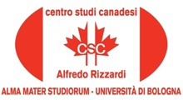
Introduction by Carla Comellini, Bologna University

The event is organized by Carla Comellini, Director of the Canadian Centre “Alfredo Rizzardi”, University of Bologna

With the Patronage of the Embassy of Canada to Italy

