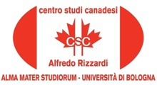

14 October, 2015, 15.30

Room IX Department Lilec, Via Cartoleria 5, Bologna

The Canadian Centre "Alfredo Rizzardi" is pleased to announce
the lecture by

Mary Condé

Rudyard Kipling's short story 'Mrs Bathurst' (1904).

Introduced by Carla Comellini

The event is organized by Carla Comellini, Director of the Canadian Centre “Alfredo Rizzardi”, in collaboration with the Cultural Program of CanaDiana, directed by Laura Ferri and with the Italo-Britannica Association of Bologna.



