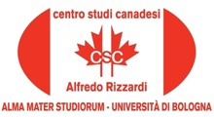

13 October, 2015, 15.30

Room VII Department Lilec, Via Cartoleria 5, Bologna

The Canadian Centre "Alfredo Rizzardi" is pleased to announce
the lecture by

Mary Condé

The role of the artist in Jane Urquhart's novel
THE UNDERPAINTER (1997)

Introduced by Carla Comellini

The event is organized by Carla Comellini, Director of the Canadian Centre “Alfredo Rizzardi, in collaboration with the Cultural Program of CanaDiana, the Association
of Canadian Studies, directed by Laura Ferri

With the Patronage of the Embassy of Canada to Italy

