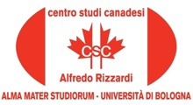

10 November, 2015, 15.30

Room VII, Lilec Department, Via Cartoleria 5, Bologna

The Canadian Centre "Alfredo Rizzardi" is pleased to announce
the Reading by the Canadian writer

Jon Redfern

A Reading from Children of the Tide
(Mystery Novel, 2015)

Introduced by Carla Comellini

The event is organized by Carla Comellini, Director of the Canadian Centre “Alfredo
Rizzardi”, in collaboration with the Cultural Program of CanaDiana, the Association
of Canadian Studies, directed by Laura Ferri and the Italo-Britannica Association of Bologna.

With the Patronage of the Embassy of Canada to Italy



