# Dreaming Europe: or, RÊVE (Romantic Europe: The Virtual Exhibition)

*Presentation: Gillian Dow, Catriona Seth, Nicola Watson*

*SLIDE: TITLE*

*SLIDE(S): ERA [bullet-points]*

The recently launched European Romanticisms in Association (ERA), founded in November 2016 In Rome, a frequent destination of European travellers during the Romantic period, brings together scholars, scholarly associations and museums devoted to the study and presentation of European Romanticisms in an exciting new, pan-European, cross-disciplinary network. (As you will note, just in time for Brexit). Its overall intellectual drive is to retrieve, revalue and re-present long-neglected transnational aspects of European Romanticisms as they emerged over the long nineteenth century. Through promoting conversation between very different traditions and institutions, we expect to stretch thinking about how best to reflect on, teach, and present European Romanticisms in the twenty-first century. The practical strategy underpinning this aim is to develop new pan-European professional and collaborative connections between academics and leading heritage organizations devoted to Romanticism. We expect in turn to produce the exchange of knowledge and ideas across national, linguistic, disciplinary, institutional and sectoral borders, and practical innovation and creative experimentation bearing on the futures of digital museum display and virtual visitor experience as well as wider pedagogical practices.

Participants include AHH, **BARS**, CETAPS, **Chawton House Library**, CISR, German Society for Eighteenth-century Studies, the French Society for Eighteenth-century Studies, the Keats-Shelley House, Rome, ICLM, Petöfi Museum, Lithouses, the Wordsworth Centre, Musée de la Vie Romantique, the Museo Byron, Museum of Romanticism Frankfurt, NARS, and SERA.

ERA is planning a series of interdisciplinary events across Europe distinguished by targeted collaboration between academic institutions and libraries, museums, galleries, theatres, and groups with an interest in Romantic cultures, of which this conference at Chawton, with its ground-breaking joint focus on Austen and Staël, is the first. These events are dedicated to exploring Romanticism as a consciously trans-European phenomenon. Events presently projected aim to explore the north, south, east and west of Romanticism in Europe. Locations include Bologna (Italy), Budapest (Hungary), Paris (France), Ravenna (Italy), Cadiz (Spain), Porto (Portugal) and Frankfurt (Germany). Projected themes include anniversaries, house-museums, the European gothic, transnational poetic form, revolutions, and translations.

*SLIDE(S): RÊVE [logo and bullet-points]*

ERA is also working on a collaborative project, RÊVE (Romantic Europe: The Virtual Exhibition). RÊVE aims to identify and consider iconic objects (conceived in the broadest sense as comprising buildings, landscapes, and artefacts) that epitomise or construct aspects of Romanticism such as romantic authorship, romantic consumption, and romantic media and bring them together in a major new public-facing collaboration, a plurilingual online museum of European Romanticisms. RÊVE is designed to develop new ways of engaging academia, cultural heritage institutions, and the wider public with a new story of European Romanticisms. It is conceived as a core research output, a central medium of cultural, intellectual, and creative exchange, collaboration, and experimentation, a mechanism for achieving impact both within and beyond academia, and a tangible, extendable project and legacy. It aims to

* display c. 100 objects
* bring untouchable, fragile things out of store and up close
* display the otherwise immovable
* bring dispersed things into conjunction for the purposes of mutual illumination
* show items from private collections rarely or never shown to the public
* interpret lost iconic objects
* narrate items in new technological formats
* dramatise exhibits by releasing exhibits on anniversaries
* include new creative responses to Romantic objects

Our intention is that it will serve

1. as a laboratory within which to experiment with the technical and rhetorical possibilities for the digital display of objects and the consequent development of ‘best practice’ including the possibilities of collaborative virtual exhibition

2. as a new, accessible, quality assured resource suitable for the study of Romanticisms at school and university level across European institutions, making important innovations and interventions in pedagogical practice

3. as a means of engaging museum-going and non-museum-going publics across Europe, building a sense of a wider European literary heritage, and encouraging further imaginary and actual touristic adventures.

*SLIDE: website address* [*http://www.euromanticism.org/*](http://www.euromanticism.org/)

*CONNECT TO WEBSITE*

RÊVE will take the form initially of a blog-post released monthly, although we hope to develop it into a cross-searchable online museum in time. We are launching this today with the three posts that are our initial contributions.

*POST 1 The European Jane Austen (Dow)*

*Image*

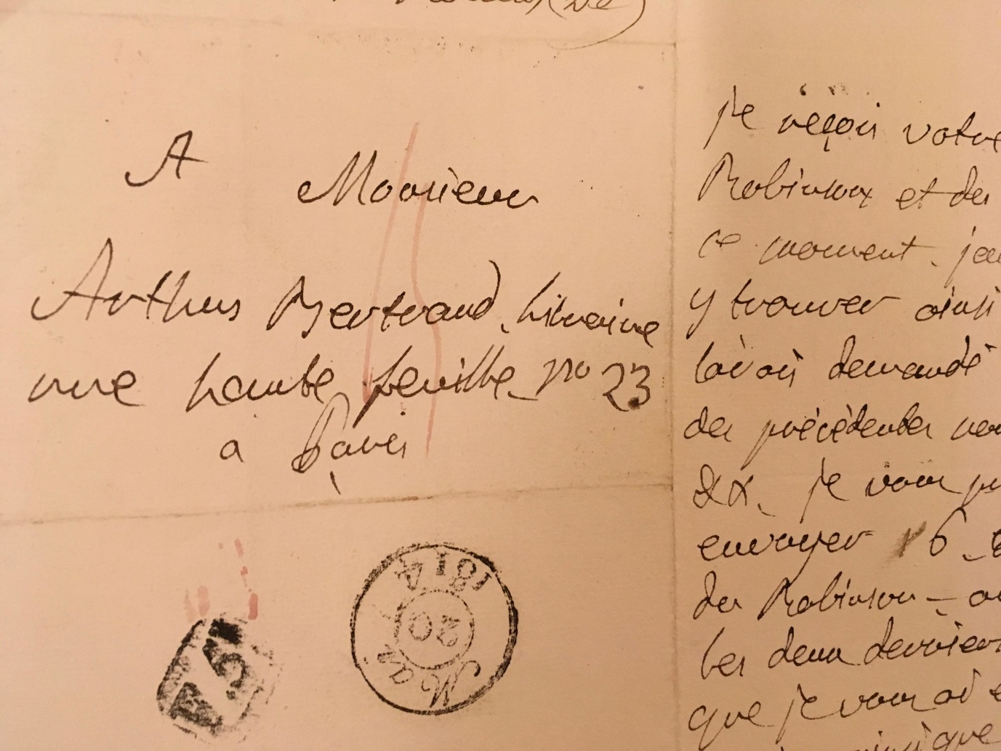

*Description: A letter from Isabelle de Montolieu to Arthus Bertrand, dated 13 May 1816.*

*On the surface, nothing links this unassuming letter – from the Franco-Swiss novelist Isabelle de Montolieu (1751-1832) to her Paris-based publisher Claude Arthus-Bertrand (1770-1834) – to ‘England’s Jane’. Yet Isabelle de Montolieu may now be best-known – or of most interest to a general reading public – as the first translator of Jane Austen. And Claude Arthus-Bertrand was Austen’s French publisher in her own lifetime – a fact certainly unknown to Austen and doubtless also unknown to John Murray II, whose publication of Austen’s* Emma *(1816) appeared in Paris under Arthus-Bertrand that same year.*

*Isabelle de Montolieu was – in her own lifetime – best known for her French sentimental novel* Caroline de Lichtfield *(1785), a ‘beauty and the beast’ type narrative. Jane Austen read it, and admired it, and it was greatly admired across Europe: Thomas Holcroft (1745-1809) the novelist, miscellanist and dramatist, was the English translator. There is considerable evidence that a great many readers in Britain admired and read the French original too.*

*The Anglo-Irish author Maria Edgeworth met Montolieu in Lausanne in September 1820. Montolieu spoke to her fellow novelist about her own composition practices: ‘I never’, said she, ‘could invent an original story – but give me the first hint and I can go on and supply all the details and characters and feelings’. This practice of ‘embellishment’ certainly informed most of Montolieu’s translations: her translation of Austen’s* Sense and Sensibility *(*Raison et Sensibilités ou les deux manières d’aimer*, 1815) takes great liberties with Austen’s source text, changing the ending radically to fit the horizon of expectations of readers of the target language, that is, the admirers of the sentimental novel on the continent.*

*There is no mention of Austen’s novels in this letter – in fact, the focus of the note is on the* Swiss Family Robinson*, the 1812 Swiss-German novel by Johann David Wyss that Montolieu translated into French in 1813. Montolieu’s celebrity and popularity was such that it was her translations that became the source text for the European spread of the novels she translated. It was her* Swiss Family Robinson *that was translated into English, and her version of Jane Austen’s* Sense and Sensibility *and* Persuasion *that travelled across Europe in the nineteenth century.*

*This letter is now owned by Chawton House Library – a recent gift from a supporter who purchased it from a bookseller in the US. It takes its place in a collection that – by its association with the author Jane Austen through her wealthy brother Edward Austen, later Edward Knight – is in itself a site of literary pilgrimage.*

*POST 2* A real Picture from the fictional Corinne’s Gallery *(Seth)*

**\*Title** (DC [title](http://dublincore.org/documents/dcmi-terms/#elements-title)) : A real Picture from the fictional Corinne’s Gallery

**\*Contributor** (DC [contributor](http://dublincore.org/documents/dcmi-terms/#elements-contributor)): Catriona Seth

**\*Description** (DC [description](http://dublincore.org/documents/dcmi-terms/#elements-description)): description of object; maximum 500-1000 words

The heroine of Germaine de Staël’s *Corinne, ou l’Italie* (1807) is a poet and improviser who displays great sensitivity to the arts. She takes the Scottish aristocrat who falls in love with her, Oswald, Lord Nelvil, around the monuments of Rome. She also shows him her own paintings and statues in her villa at Tivoli. Her collection was probably imagined on the basis of Angelica Kauffmann’s which the novelist had seen. Among the paintings in the fictional character’s gallery is a landscape which she presents thus: ‘je n'aime pas beaucoup les scènes champêtres, qui sont fades en peinture comme des idylles, quand elles ne font aucune allusion à la fable ou à l'histoire. Ce qui vaut le mieux, ce me semble, en ce genre, c'est la manière de Salvator Rosa, qui représente, comme vous le voyez dans ce tableau, un rocher, des torrents et des arbres, sans un seul être vivant, sans que seulement le vol d'un oiseau rappelle l'idée de la vie. L'absence de l'homme au milieu de la nature excite des réflexions profondes. Que serait cette terre ainsi délaissée? Œuvre sans but, et cependant œuvre encore si belle, dont la mystérieuse impression ne s'adresserait qu'à la divinité.’[1]

Corinne’s artworks play a role in her story and allow her to discuss ideas which matter to her. She uses this painting to evoke forms of transcendence, which tap into a frequently shared Romantic anguish about mankind’s place on earth: in literary works, the scenes we behold often mirror feelings—and we have an indication of the character’s deep melancholy and inner solitude to come with this vision of an uninhabited rural landscape. The 17th-century vista hangs on her walls with pictures by contemporaries and allows us to gain an insight into what an artistically-minded young woman might be expected to appreciate at the start of the 19th century. It is an Italian painting chosen by an Italo-British character imagined by a francophone writer born in Paris to Swiss parents and married to a Swedish diplomat. It demonstrates the pan-European circulation of objects and individuals.

*Corinne* was Staël’s second novel. It was a huge success and was soon translated into several languages. The main character, who lives alone in Rome at the opening, with no family, and uses a pseudonym to hide her true identity, gives public performances of her improvisations and was seen as a model by many women writers. Staël puts Corinne and Oswald’s doomed love-story in the foreground but also considers the way in which the arts and culture could serve to underline common concerns and therefore to achieve political unity in Italy, which at the time was made up of a series of small States. The Risorgimento, the movement which led to Italian independence, recognised its debt to Staël as the first major European writer to have given an impetus to the idea that language and culture could lead to the resurgence of a great nation.

The painting’s exceptionality nowadays is not its attribution—it is no longer considered to be a Salvator Rosa—but its provenance. A 19th-century label on the back of the canvas reads: ‘Ce paysage de Salvator Rosa est celui dont Mme de Stael parle dans Corinne L. VIII Ch. IV. Il a appartenu à Mr Auguste Pasquier qui avait été grand ami de Mme Récamier et de Mme de Stael.’[2] Paradoxically, it is this hidden addendum (when the picture, as it should, hangs on a wall, the label is invisible) which infuses new interest into the scene and gives it an association with individuals and characters—the personal touch which Corinne so loved. By the place it occupies in an important work of the romantic period, as evidenced by the 19th-century owner’s note, this much earlier landscape has acquired a new layer of meaning.

**\*Date:** (DC[date](http://dublincore.org/documents/dcmi-terms/#elements-date)) : mid 17th-c.—label mid 19th c.

**Creator** (DC [creator](http://dublincore.org/documents/dcmi-terms/#elements-creator)) : Formerly attributed to Salvator Rosa (1615-1673).

**\*Subject** (DC [subject](http://dublincore.org/documents/dcmi-terms/#elements-subject)) : Germaine de Staël/Salvator Rosa.

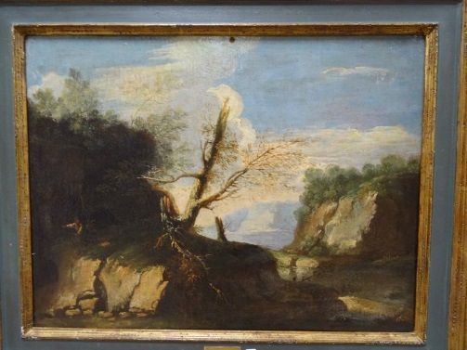

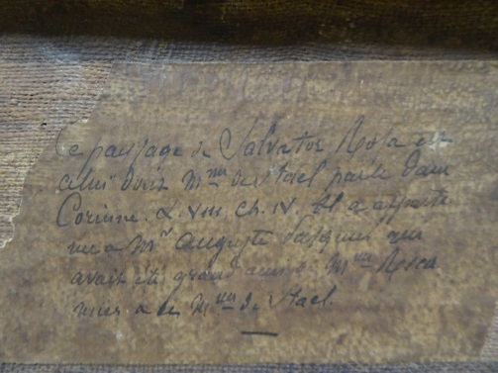

**\*Media**: One or more image, audio or video files relating to the object.

**\*Media rights:** (DC[rights](http://dublincore.org/documents/dcmi-terms/#elements-rights)): Information about rights held in and over the digital reproduction of the object.

**Object type** (DC [type](http://dublincore.org/documents/dcmi-terms/#elements-type)): Painting.

**Format** (DC [format](http://dublincore.org/documents/dcmi-terms/#elements-format)): Oil on canvas.

**Language** (DC [language](http://dublincore.org/documents/dcmi-terms/#elements-language)): French (for the label)

**Related objects** (DC [relation](http://dublincore.org/documents/dcmi-terms/#elements-relation)) : An identifier of a second object within the RÊVE collection and its relationship to the present object. Could be useful if there is another object by same person, but I do not think it is strictly indispensable

**\*Publisher** (DC [publisher](http://dublincore.org/documents/dcmi-terms/#elements-publisher) ): Catriona Seth.

**\*Location** (DC [coverage](http://dublincore.org/documents/dcmi-terms/#elements-coverage)): Private Collection.

**Digital collection record** (DC [source](http://dublincore.org/documents/dcmi-terms/#elements-source)) : A related resource from which the described resource is derived. Link to existing digital catalogue record, if present. DOI preferred; then any stable link format.

**Catalogue number** (DC [identifier](http://dublincore.org/documents/dcmi-terms/#elements-identifier)) : museum/archive/library identifier of the object, if known

*POST 3 Rousseau’s trapdoor (Watson)*

*Image*

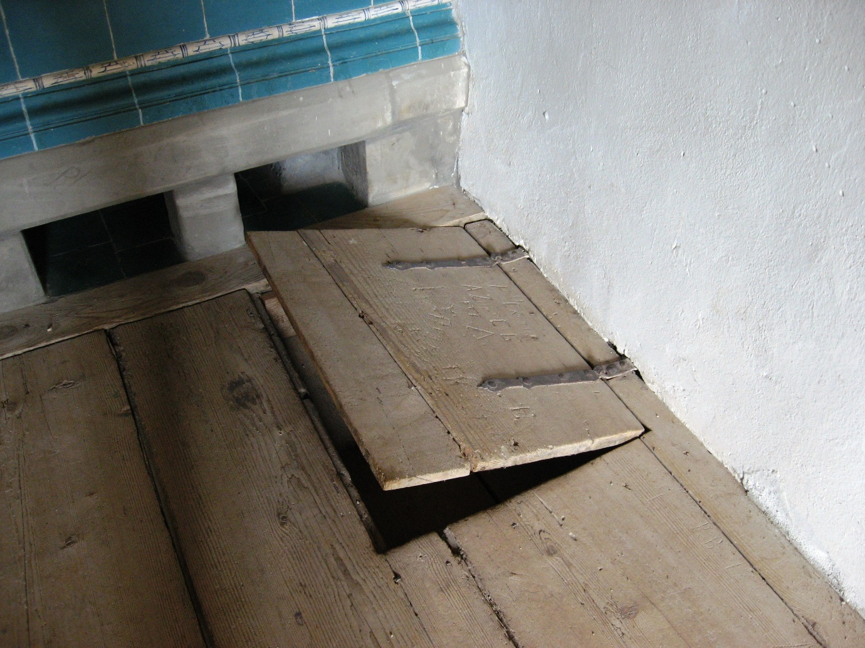

*Description: A wooden trapdoor set within the floor in the corner of a first-floor bedroom in the sole farmhouse on the Île St Pierre in the Lac de Bienne, Switzerland. Both its date of origin and original use are obscure. It achieved celebrity in the last decade of the eighteenth century through its association with the philosopher, novelist and essayist Jean Jacques Rousseau (1712-1778), and in particular with his posthumously published autobiographical writings, both the latter part of the* Confessions *(published first in 1789) and the volume of essays entitled* Les Rêveries du Promeneur Solitaire *(composed between 1776 and 1778, published in 1782). The fifth ‘Rêverie’ deals at length with Rousseau’s stay in the farmhouse on the Île for six weeks in the summer of 1765 before being expelled as a political undesirable and departing for England. Both the* Confessions *and the* Rêveries *describe this summer as an idyllic pause in a sequence of persecutions and exiles.*

*This trapdoor achieved celebrity because it came to sum up Rousseau’s sojourn on the island. For Rousseau, the island offered him an escape. The trapdoor exemplified this, as it was said to be the way that he had escaped unwanted visitors. The beginnings of this story date from before the publication of either the* Confessions *or the* Rêveries*. The trapdoor itself was first mentioned in an account written in 1777 by a man called M. Desjobert of his literary pilgrimage to sites associated with the writer, including a visit to Rousseau’s bedroom, and the story was elaborated eleven years later in 1788 when it was first said that the trapdoor had provided a way for Rousseau to avoid ‘importuns.’ The numbers of the importunate to the farmhouse would only increase over the next twenty years, apparently providing an income for the family who owned the property: in 1822 Louis Simond rather sourly noted that the farmhouse was now ‘a house of entertainment for curious travellers’ and that ‘a portly Swiss beauty, our landlady, introduced us to Rousseau’s room, in the state he left it, very scantily furnished, and the bare walls scribbled over with …enthusiastic rhapsodies about the Genevan philosopher’ (I, 62-3). The remains of these signatures and effusions are still on view. Tourist interest in the island was great enough to warrant the publication of a guidebook as early as 1815,* L’Île S Pierre dite L’Île de Rousseau, dans le lac de Bienne à Berne*, authored by ‘Sigismond Wagner’. Its account of the trapdoor is still more circumstantial. Having described the view from the window it observes that:*

*Outre de l’agrément de cette vue, un avantage particulier avoit décidé Rousseau à donner la preference à cette chamber sur toutes les autres de la maison, c’étoit un escalier dérobé qui conduisoit, au moyen d’une trappe, dans une chambre du rez-de-chaussée et de-là dans la campagne. Rousseau s’échappoit souvent par cette issue, quand le bruit qui se faisoit dans le corridor l’avertissoit de l’approche de quelque visite importune, et se hâtoit de se soustraire à leur vaine curioisité, en se réfugiant dans les endroits les plus solitaires du bois… (74).*

*[Besides the attraction of this view, one advantage in particular decided Rousseau’s preference for this room over all the others in the house, a secret staircase which led him, by way of a trapdoor, into a ground-floor room and from there into the countryside. Rousseau often escaped by this exit, when the noise in the corridor alerted him to the approach of some importunate visit, and he hastened to escape their vain curiosity by taking refuge in the most solitary places of the woods…]*

*In 1819, this story had enough traction to inform a depiction of the bedroom in* Vues de différentes habitations de J. J. Rousseau*, which shows the philosopher vanishing through the trapdoor in the floor in order to escape the well-dressed visitors coming in through the door to pay their respects.*

*For Rousseau’s admirers and mythologizers this trapdoor came to epitomise the writer’s notorious disinclination to society’s surveillance and his preference for the delights of his own imagination, and in particular, reverie. The fame of the trapdoor attested, too, to a longing on the part of readers to experiment with being Rousseau through sharing in his fantasy of the Ile St Pierre as an exit from the pressures of the world. More nebulously, the trapdoor epitomised the newly fashionable experience of visiting the home of a now-dead author; it suggested that the reason why tourists do not find Rousseau at home is that he has hastily and characteristically popped out to avoid them. The trapdoor thus describes in little the emerging phenomenon of romantic period literary tourism: the desire to supplement reading by visiting the scenes described by the author, so as to experiment with inhabiting that subjectivity more fully. The fame of this site attests to the pan-European cosmopolitan appeal of becoming Rousseau, attracting admirers from across Europe and Russia.*

*SLIDE COMING NEXT*

Upcoming posts include mini-essays on Teresa Guiccioli’s keepsake of Byron’s hair, the significance of the Cadiz mortar, Thomas Moore’s harp, and Bettina von Arnim’s handbag. To sign up for e-mail alerts* go to… If you would like to contribute yourself to RÊVE please contact Nicola Watson in the first instance at [nicola.watson@open.ac.uk](mailto:nicola.watson@open.ac.uk).

1. I do not like rural scenes that bear no allusion to fable or history; they are insipid as the idols of our poets. I prefer Salvator Rosa’s style here, which gives you rocks, torrents, and trees, with not even the wing of a bird visible to remind you of life! The absence of man, in the midst of nature, excites profound reflections. What is this deserted scene, so vainly beautiful, whose mysterious charm address but the eye of their Creator?
2. This landscape by Salvator Rosa is the one of which Mme de Staël speaks in *Corinne*, book VIII, ch. IV. It belonged to Mr Auguste Pasquier who was a great friend of Mme Récamier and Mme de Staël.